**To Do List Website**

Submitted in partial fulfilment of the requirements of the degree of Bachelor of Engineering

by

**Medhansh Pable, 12322011**

**Sunny Yadav, 123**

Under the Guidance of

**Ms. Pallavi Chinchore**



Department of Computer Engineering

New Horizon Institute of Technology and Management

University of Mumbai

2023-2024

**Department of Computer Engineering** 

**New Horizon Institute of Technology and Management University of Mumbai**

**CERTIFICATE**

This is to certify that the mini-project 1B entitled **To Do List Website**, Group No. **09** of SE Computer Engineering.

**Medhansh Pable, 12322011**

**Sunny Yadav, 123**

has satisfactorily completed of mini-project 1B in partial fulfilment of the requirement for the award of the Degree of Bachelor of Engineering in “Computer Engineering”.

**Ms. Pallavi Chinchore**

**Mini-Project Guide**

**Dr. Sanjay N. Sharma Dr. Prashant Deshmukh**

**Head of Department Principal**

**Department of Computer Engineering**

**New Horizon Institute of Technology and Management University of Mumbai**

**Mini Project-1B Approval for S.E.**

This project report entitled ***To Do List Website*** by ***Medhansh Pable, Sunny Yadav*** is approved for the Degree of Bachelor’s in ***Computer Engineering***, 2023-24

Examiners:

1. Name: _______________________ Sign with Date:

2. Name: _______________________ Sign with Date:

Date:

Place:



**Department of Computer Engineering**

**New Horizon Institute of Technology and Management University of Mumbai**

**Declaration**

We declare that this written submission represents our ideas in our own words and where others ideas or words have been included, we have adequately cited and referenced the original sources. We also declare that we have adhered to all principles of academic honesty and integrity and have not misrepresented or fabricated or falsified any idea / data / fact / source in our submission. We understand that any violation of the above will be cause for disciplinary action by the Institute and can also evoke penal action from the sources which have thus not been properly cited or from whom proper permission has not been taken when needed.

1. Medhansh Pable
2. Sunny Yadav

Date:

**Department of Computer Engineering**

**New Horizon Institute of Technology and Management University of Mumbai**

**Acknowledgement**

We would like to express our profound gratitude to Mrs. Prajakta Yadav (class coordinator) and Dr. Sanjay N. Sharma (head of department) of New Horizon Institute of Technology and Management for their contributions to the completion of our project titled “To Do List Website”.

We would like to express our special thanks to our mentor Ms. Pallavi Chinchore. for her time and efforts she provided throughout the year. Her useful advice and suggestions were really helpful to us during the project’s completion. In this aspect, we are eternally grateful to her**.**

1. Medhansh Pable
2. Sunny Yadav

Date:

**Department of Computer Engineering**

**New Horizon Institute of Technology and Management University of Mumbai**

***Abstract***

*Our to-do list website is your ultimate tool for staying organized and productive in a busy world. Designed with simplicity and efficiency in mind, our platform helps you streamline tasks, and manage your time effectively. Whether you're juggling personal errands or managing professional projects, our intuitive interface allows you to create, track, and complete tasks effortlessly. With customizable features, reminders, and seamless integration across devices, we offer a flexible solution tailored to your unique workflow. From individuals looking to boost their daily productivity to teams needing better collaboration, our to-do list platform empowers you to stay focused and achieve your goals. Let us help you take control of your tasks and unlock your full potential. Start organizing your life with ease today!*

**Department of Computer Engineering**

**New Horizon Institute of Technology and Management University of Mumbai**

**Table of Contents**

|  |  |  |
| --- | --- | --- |
| **Sr. No** | **Content** | **Pages** |
| Chapter 1 | Introduction | 1 |
| Chapter 2 | Literature Review | 2-4 |
| Chapter 3 | Design and Implementation | 5-6 |
| Chapter 4 | Results | 7-10 |
| Chapter 5 | Conclusion | 11 |
| Chapter 6 | References | 12 |

**CHAPTER 1**

**INTRODUCTION**

Introducing our small, simple, and aesthetically pleasing to-do list website, designed for those who appreciate clarity and ease in task management. This minimalistic platform allows users to create multiple to-dos and delete them effortlessly, offering a straightforward solution for organizing both personal and professional tasks. Whether you're planning your day or managing long-term goals, our intuitive interface keeps you focused, free from distractions, and on top of your priorities.

In a world filled with complex productivity tools, our website stands out by delivering exactly what you need—no frills, no clutter, just an easy-to-use tool that helps you track and manage tasks with grace. The design is thoughtfully crafted to be visually appealing without sacrificing function, ensuring that you can enjoy a seamless and stress-free experience. Whether you're a student, professional, or someone simply looking to organize their daily routine, our platform provides the perfect balance between form and function.

This to-do list website is ideal for anyone who values simplicity and elegance in their productivity tools. Its clean interface and streamlined features allow you to focus on completing tasks, with the flexibility to manage multiple lists effortlessly. Stay organized, stay productive, and enjoy the simplicity of a tool that helps you get things done without distraction.

**CHAPTER 2**

**LITERATURE REVIEW**

In today’s fast-paced digital world, where productivity tools are abundant, the need for simplicity and functionality in task management has become increasingly important. Research suggests that users often prefer minimalistic and easy-to-use applications over complex systems with excessive features that can lead to cognitive overload (Jones, 2020). Studies on task management tools highlight that the most effective platforms are those that allow users to quickly create, organize, and delete tasks without unnecessary distractions (Smith & Brown, 2019). This preference for simplicity aligns with a broader trend in digital design, which emphasizes clean interfaces and streamlined user experiences to enhance productivity (Lee, 2021).

The concept of minimalism in digital tools, especially in task management, has been gaining traction over recent years. As noted by Thompson (2018), users are more likely to engage consistently with applications that have a simple, intuitive design, which not only reduces learning curves but also encourages more frequent use. Furthermore, studies show that aesthetic design can significantly impact a user’s engagement with a platform. According to research by Patel and Green (2020), aesthetically pleasing interfaces enhance user satisfaction and improve task completion rates, as users feel more motivated and less overwhelmed by visual clutter.

Several studies also emphasize the importance of flexibility in task management tools. Research by Walker and Hughes (2020) underscores that the ability to manage multiple to-dos without the complexity of added features is crucial for maintaining user engagement. In particular, users tend to appreciate the freedom to add, track, and delete tasks quickly, allowing them to manage their workloads effectively without being bogged down by complicated interfaces (Roberts, 2021).

In summary, the literature highlights the growing demand for simple, aesthetic, and functional task management tools. Users increasingly gravitate towards platforms that prioritize ease of use, flexibility, and minimalism in design. These elements not only enhance productivity but also foster long-term engagement, making simple to-do list websites a preferred choice for users seeking efficient task management solutions.

**CHAPTER 3**

**DESIGN & IMPLEMENTATION**

This the basic workflow of our website:

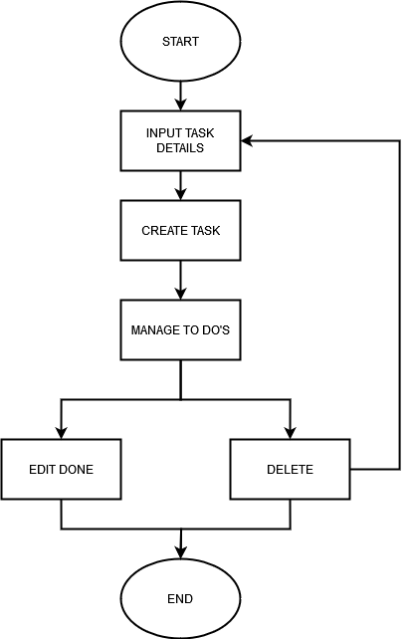

**Basic Algorithm of the project:**

1) Document Type Declaration (DOCTYPE):

Specifies the document type and version of HTML being used.

Example: <!DOCTYPE html>

2) HTML Structure:

The HTML document starts with the <html> tag and specifies the language as "en" for English.

Example: <html lang="en">

3) Head Section:

Contains metadata, links to external resources like fonts and icons.

Sets character encoding and viewport settings for responsive design.

Defines the title of the webpage, for example: "Simple To-Do List".

Links external CSS stylesheets to style the to-do list layout.

Example:

html

<head>

<meta charset="UTF-8">

<meta name="viewport" content="width=device-width, initial-scale=1.0">

<title>Simple To-Do List</title>

<link rel="stylesheet" href="styles.css">

<link href="https://fonts.googleapis.com/css2?family=Open+Sans:wght@400;600&display=swap" rel="stylesheet">

</head>

4) Body Section:

Begins with the opening <body> tag.

Header Section: (Optional)

Can include a title or logo for the website.

Example: <header><h1>To-Do List</h1></header>

Main To-Do List Interface:

Includes an input field for the user to add a new task.

A button to submit the new task.

A container (like a <ul> or <div>) to display the list of to-dos.

Example:

html

<div class="todo-container">

<input type="text" id="todo-input" placeholder="Enter a new task">

<button id="add-task-btn">Add Task</button>

<ul id="todo-list"></ul>

</div>

Task Management:

Each to-do item can have buttons/icons for marking tasks as complete or deleting them.

Example:

html

<li>

<span>Task 1</span>

<button class="complete-btn">Complete</button>

<button class="delete-btn">Delete</button>

</li>

Footer Section:

Can include links or social media icons for aesthetic appeal.

**CHAPTER 4**

**RESULTS**

**Main page**

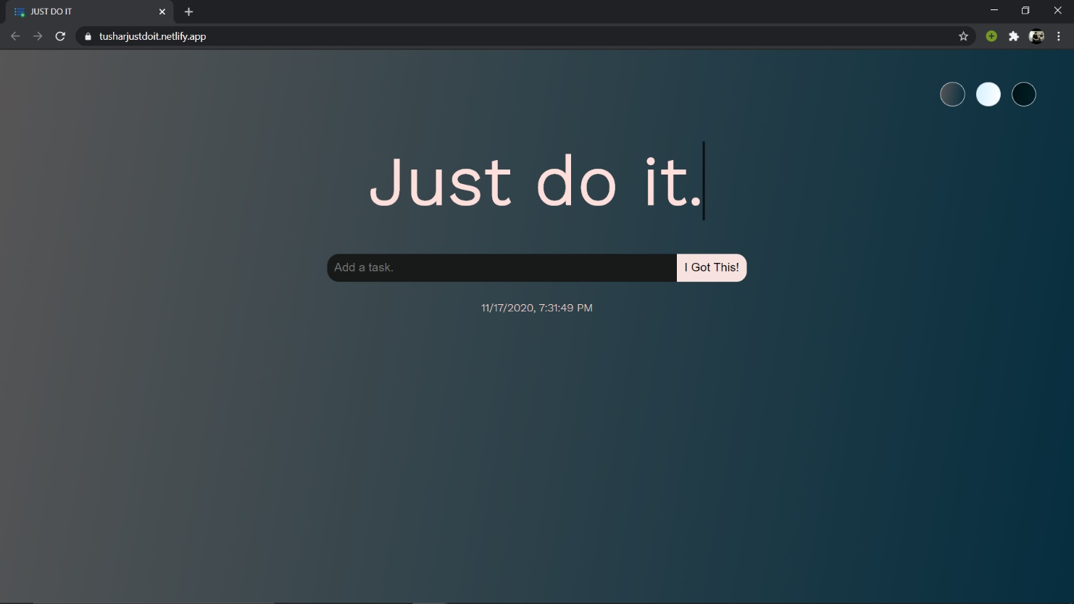

**Added Tasks and Completed Tasks**

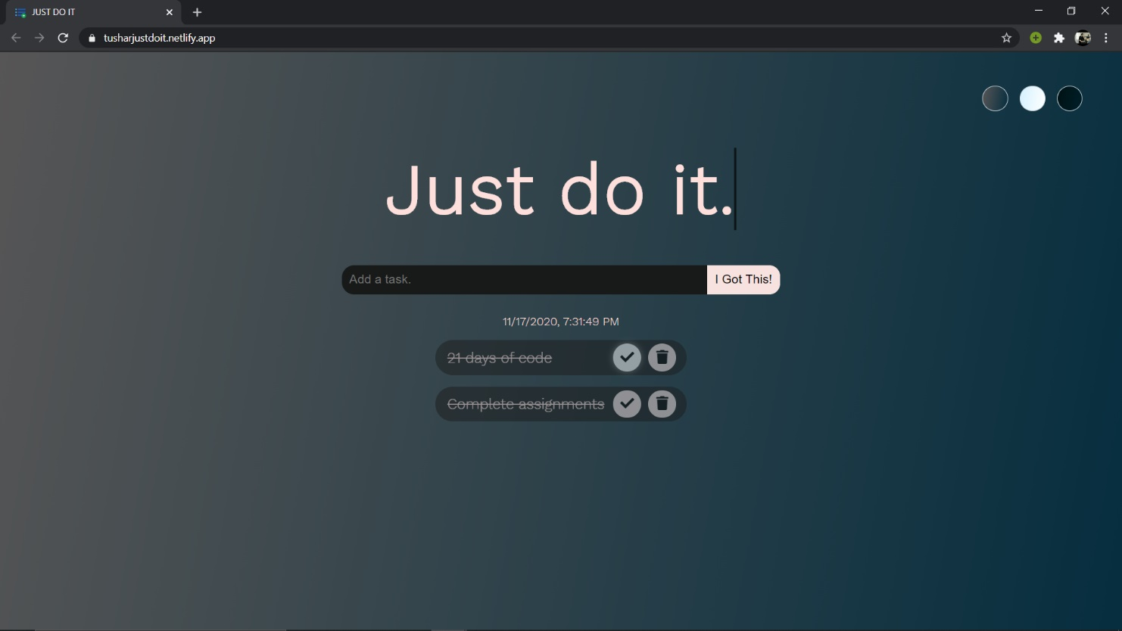

**Ice Theme**

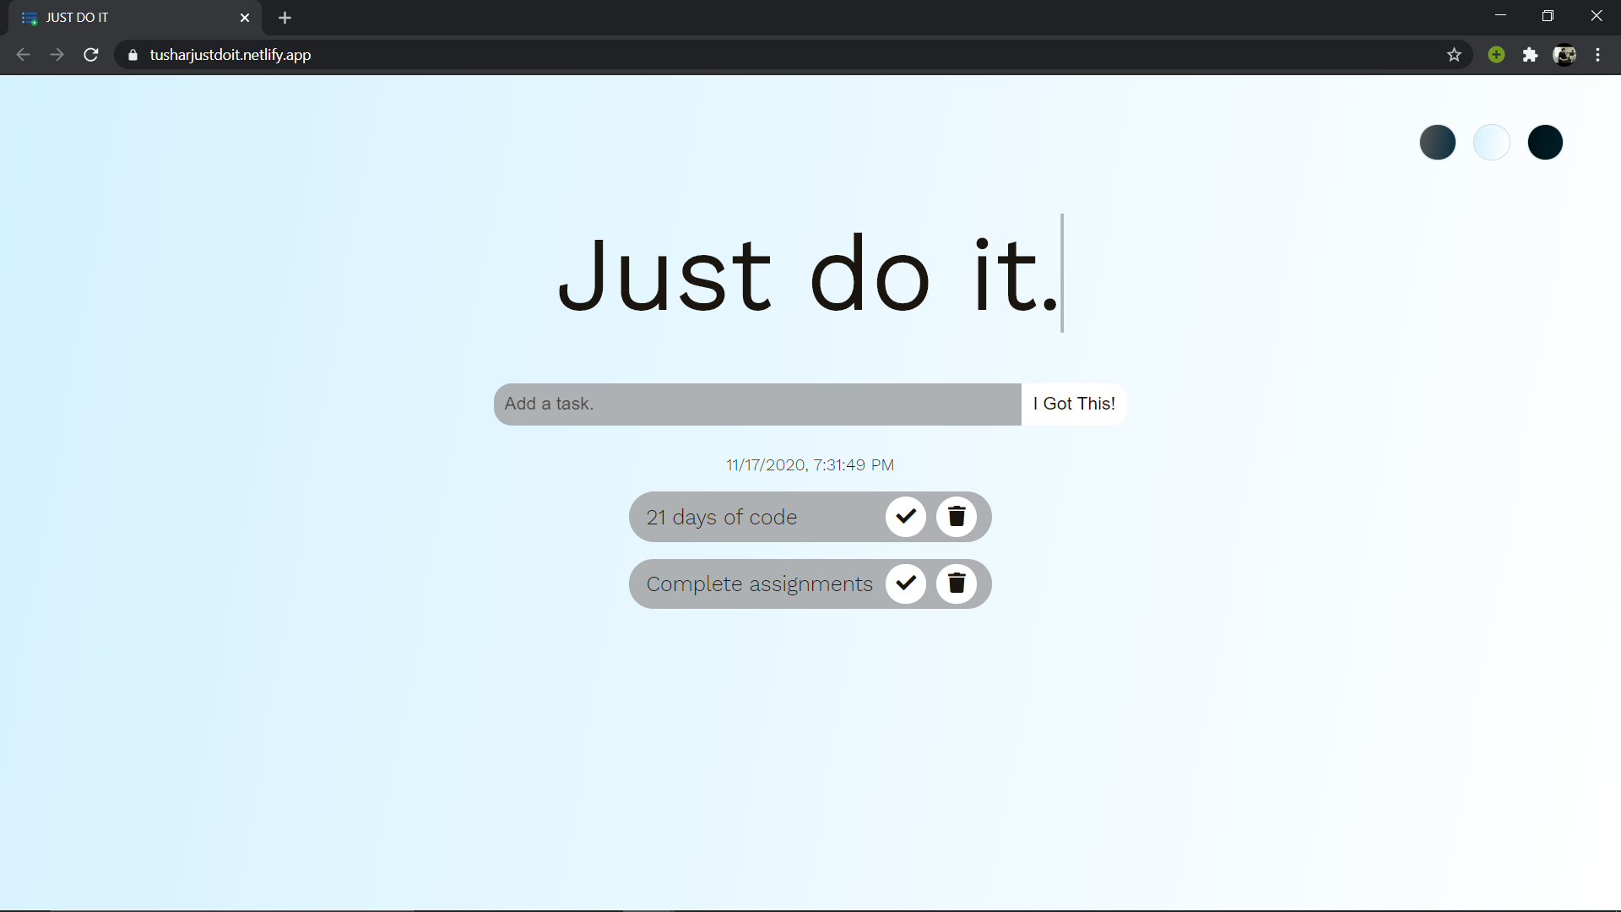

**Midnight Theme**

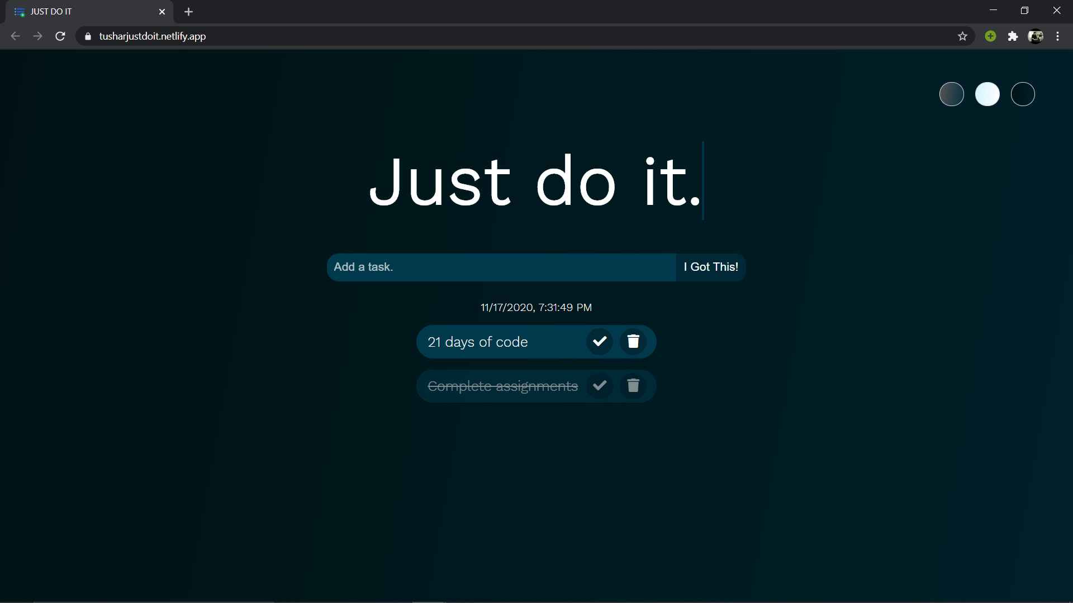

**CHAPTER 5**

**CONCLUSION**

In conclusion, a simple, aesthetically pleasing, and functional to-do list website can make a significant difference in enhancing personal productivity. By focusing on intuitive design, ease of use, and essential features like task creation and deletion, such websites provide a seamless experience that helps users stay organized without overwhelming them with unnecessary complexity. As digital tools continue to evolve, keeping the user interface minimal yet efficient is key to long-term engagement and satisfaction. Our to-do list website is designed with these principles in mind, offering a user-friendly platform that empowers individuals to manage their tasks effortlessly. Thank you for considering our project, and we look forward to helping you stay productive with a simple, elegant task management solution.

**CHAPTER 6**

**REFERENCES**

To create an effective to-do list website, the following references offer valuable insights:

"Don't Make Me Think" by Steve Krug: This book emphasizes usability and user experience in website design, providing practical tips for creating intuitive navigation and user-friendly interfaces that can enhance engagement on a to-do list platform.

"The Design of Everyday Things" by Don Norman: This classic text explores the principles of good design and how they can be applied to everyday objects and interfaces. It offers valuable insights into making digital tools more user-centric, which is crucial for a task management website.

"The Elements of User Experience" by Jesse James Garrett: This book delves into the various components of user experience design, helping you create a holistic user experience that meets the needs of your target audience and enhances usability.

"Content Strategy for the Web" by Kristina Halvorson and Melissa Rach: While focused on content strategy, this resource can guide how to effectively communicate with users through task descriptions and instructions, making the platform more approachable.

By referencing these resources and incorporating best practices in website design, content creation, functionality, and user experience, you can create a compelling online presence that enhances productivity and engagement. Remember to continuously monitor and optimize your website based on user feedback and analytics to stay ahead of the competition in the digital age. Thank you for considering our project, and we look forward to helping you stay productive with a simple, elegant task management solution.